Exercise 2: Verifying Interactions – Progress Report
This document summarizes the work completed for the Mockito 'Verifying Interactions' exercise in IntelliJ IDEA, including the code written, an issue encountered, the fix applied, and the final test results with console output.

Exercise 2: Verifying Interactions
Goal: Ensure a mocked method is actually invoked by using Mockito's verify() to confirm the interaction between the service and the mock.

Code Implemented
@Test
public void testVerifyInteraction() {
ExternalApi mockApi = Mockito.mock(ExternalApi.class);
MyService service = new MyService(mockApi);
service.fetchData();
verify(mockApi).getData();
System.out.println("Verified that getData() was called on mockApi.");
}

Issue Encountered and Fix
- While adding the second test method, it was accidentally duplicated in the class, causing a build error: "method testVerifyInteraction() is already defined in class org.example.MyServiceTest".
- Fix: The duplicate method block was located and deleted, keeping only a single, correct definition of testVerifyInteraction().
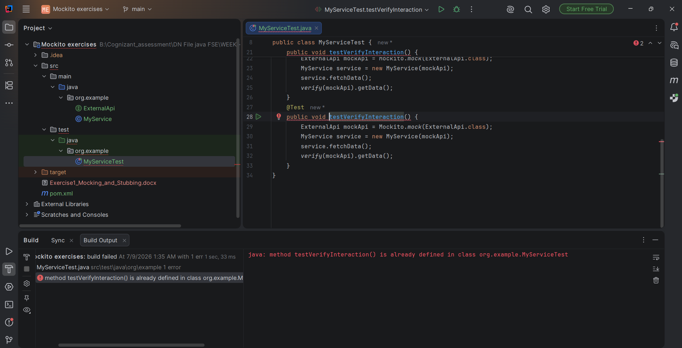
Figure 1: Build error caused by an accidental duplicate method definition
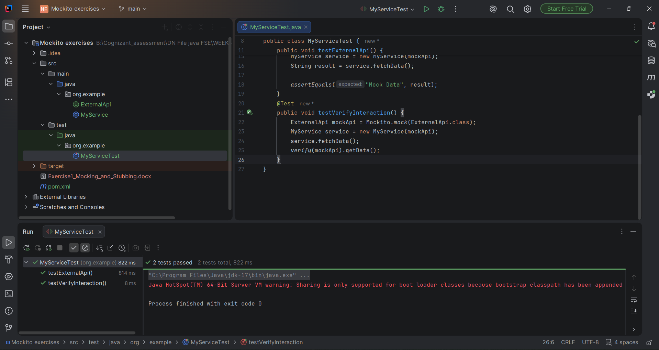
Figure 2: After removing the duplicate, both tests passed (2 tests total)

Final Run – Console Output
System.out.println() statements were added to both tests so the results of mocking and verification are visible directly in the Run console, in addition to the test pass/fail status.
Result from mock API: Mock Data
Verified that getData() was called on mockApi.

Process finished with exit code 0
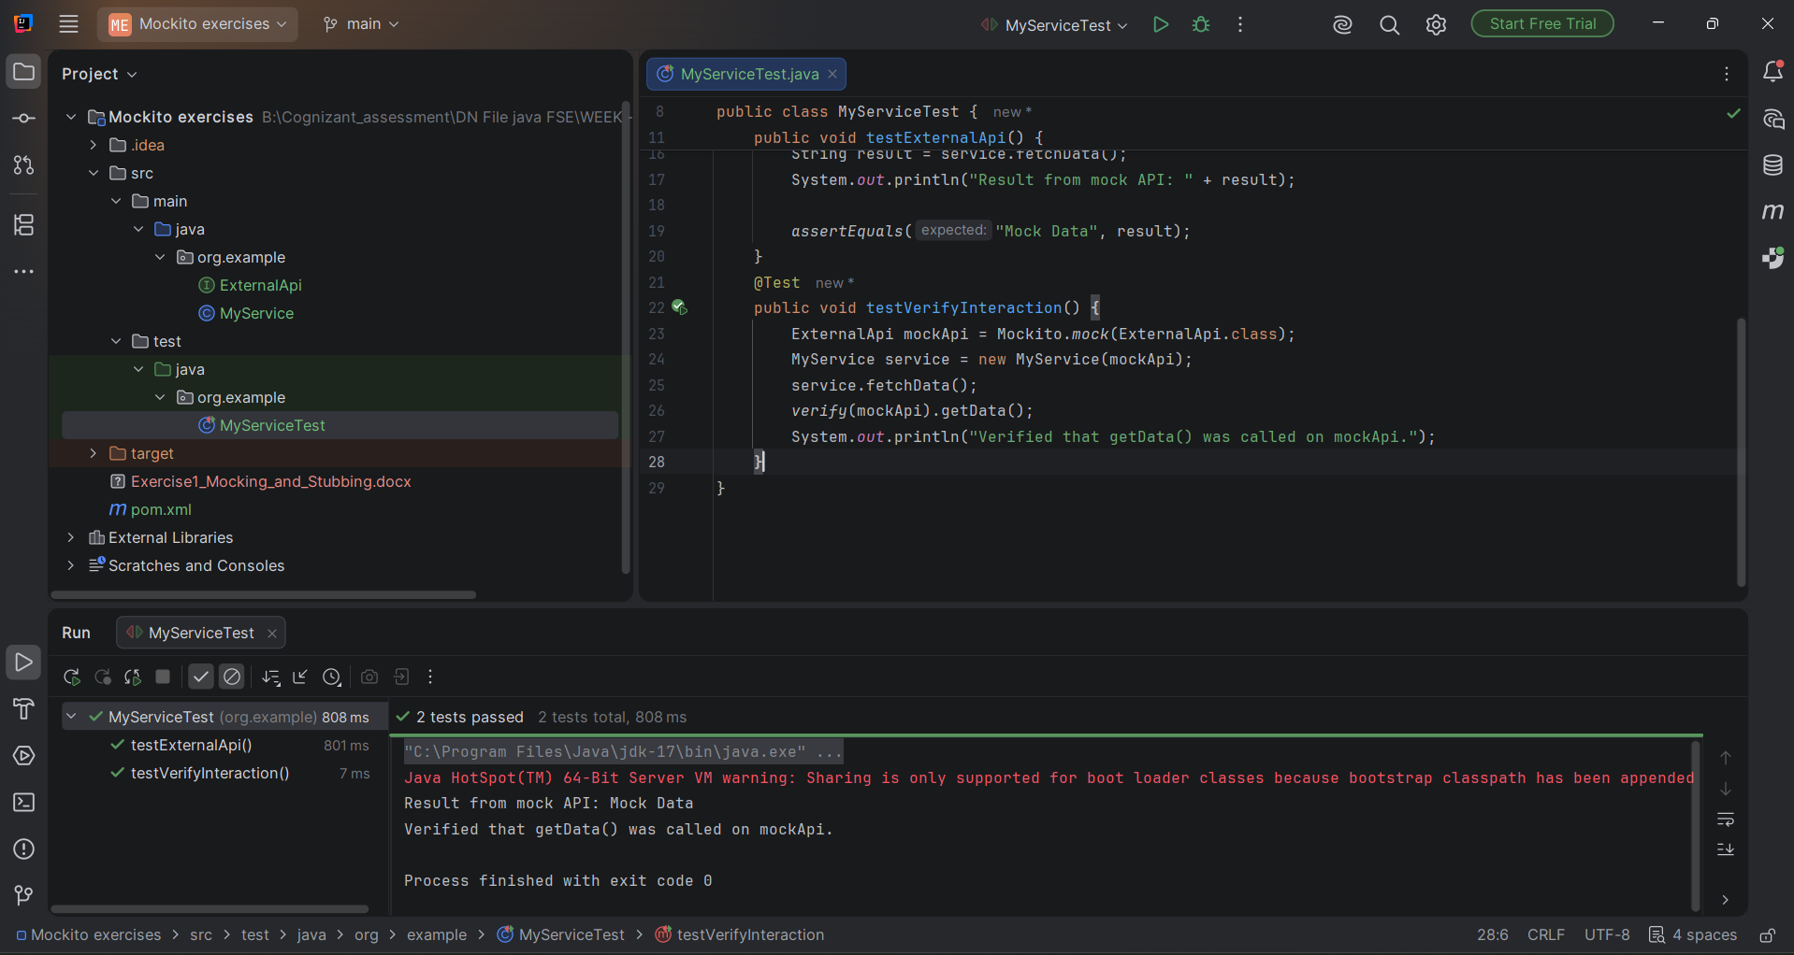
Figure 3: Final run — both tests passed with console output showing mock result and verification message

Summary
- Exercise 2 (Verifying Interactions) implemented and completed.
- A duplicate method definition issue was identified and resolved during implementation.
- Console output added via System.out.println() to visibly confirm the verified interaction.
- Final result: 2 tests passed, 0 failures.

